**Experiment -2**

|  |
| --- |
| **Name: Rahul Maurya**  **UID: 20BCS7260**  **Class: 807 A**  **Subject: Multimedia Lab** |

**Aim:** Procedure to remove the arrows and text from the given photographic image using Adobe photoshop.

**Hardware Requirements: -** Minimum 384MB RAM, 100 GB hard Disk, processor with 2.1 MHz

**Software Requirements: -** Adobe Photoshop, Photopea

**Tools to be used:** Type Tool, Rectangle select(M), Lasso select.

**Study:**

**2.1 Procedure to remove text from a given image.**

**Step 1 :-** Create the new project and set the dimensions according to the requirement.

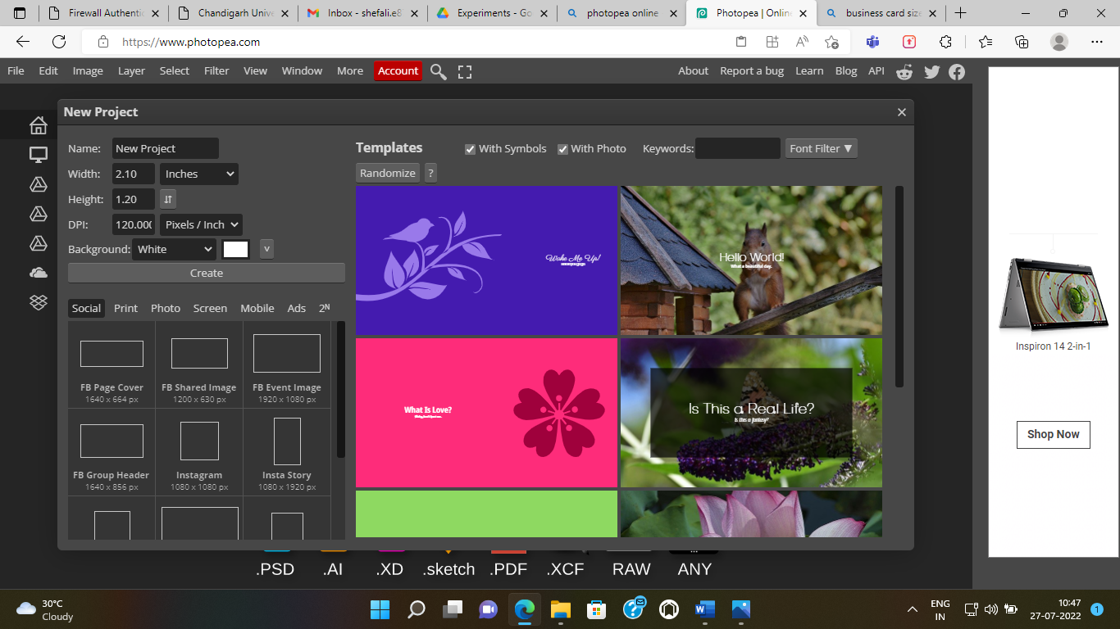

**Step 2: -** Now you have to select the layer1 image for the removing text from the given photographic image . You can take images through various methods.

1. If the image is in your system, then you can take it from FILE ---> Open and place.
2. 2. You can copy the image and paste it on the template.
3. 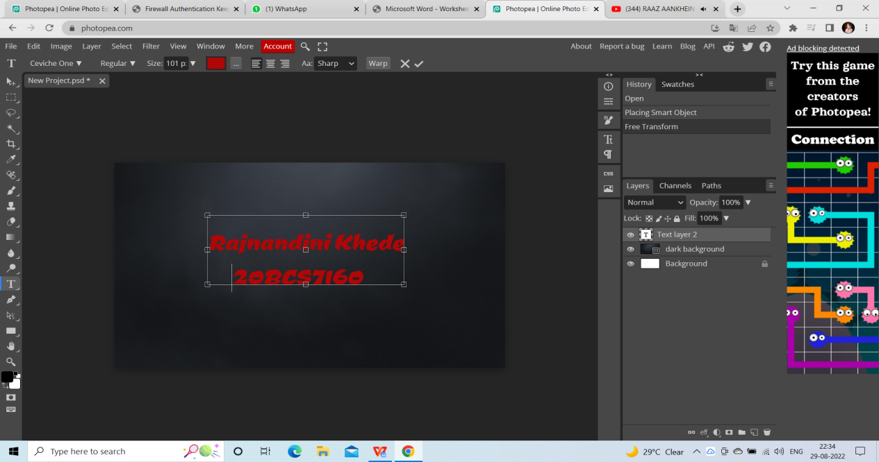

**Step3:-** Brush tool.

**Step4:**- Select the Size & Hardness of the brush tool.

**Step5:**- Start removing the text.

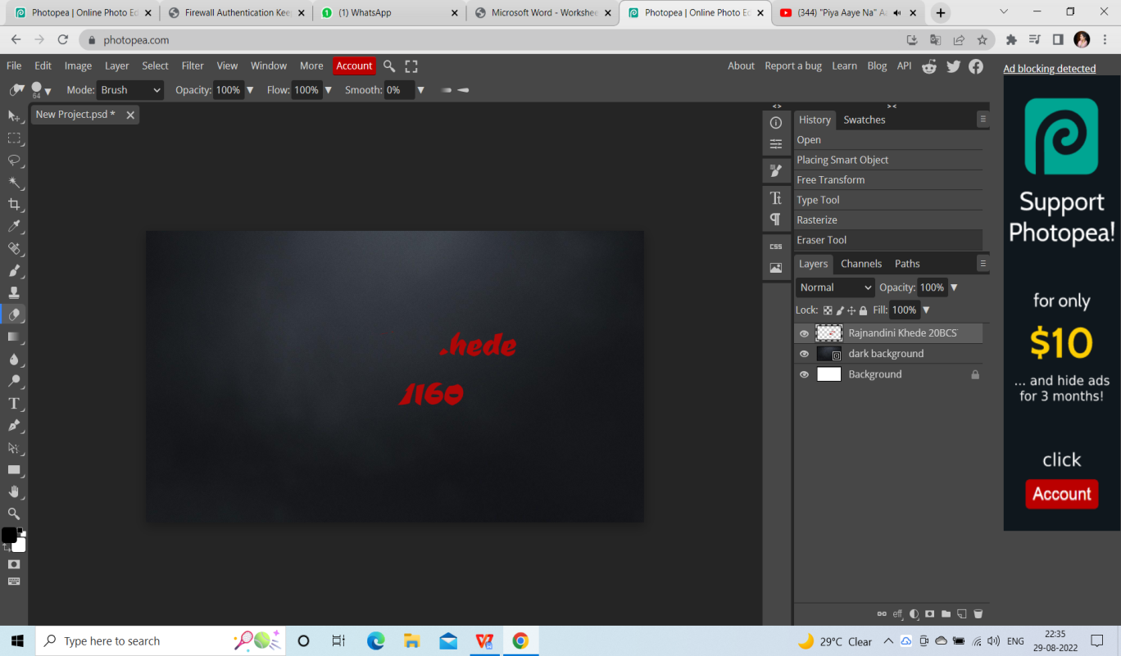

**Output:-**

**Step5:**- Text removed.

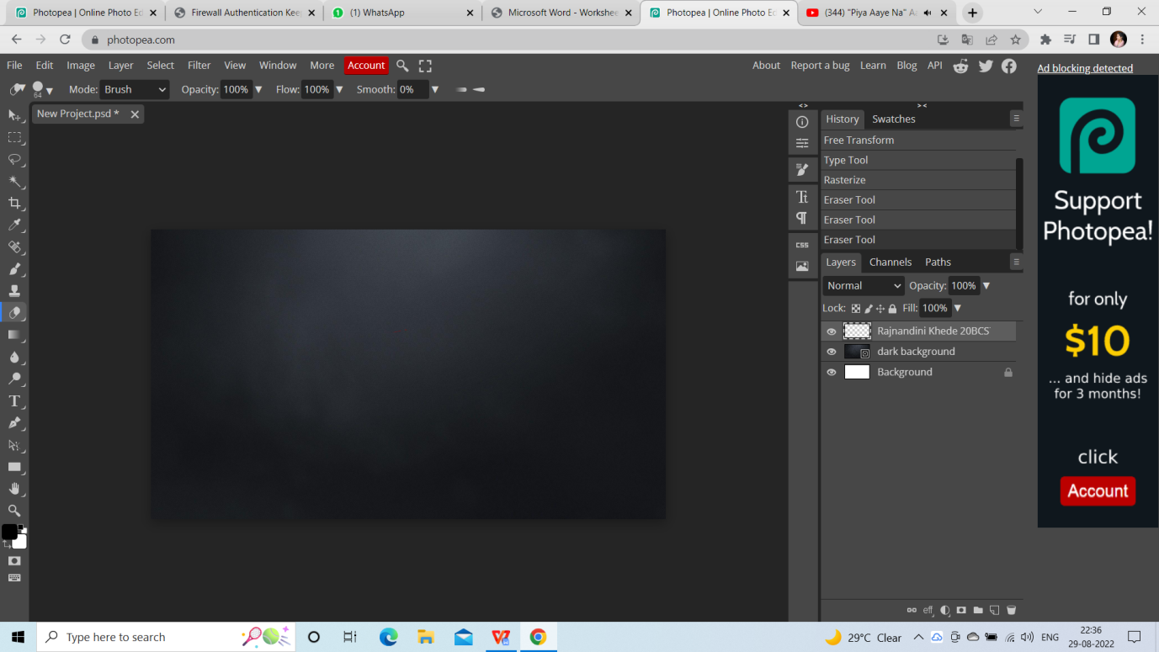

**2.2 Procedure to remove an object from a given image.**

**Step 1 :-** Create the new project and set the dimensions according to the requirement.



**Step 2: -** Now you have to select the layer1 image for the removing object from the given photographic image . You can take images through various methods.

1. If the image is in your system, then you can take it from FILE ---> Open and place.

2. You can copy the image and paste it on the template.

**Step 3: -** After that we have to select rectangular box then Lasso Select**.**

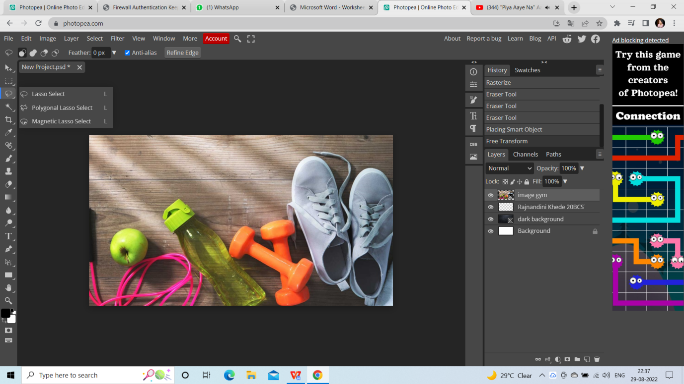

**Step4:-** Then select the object part of the image.

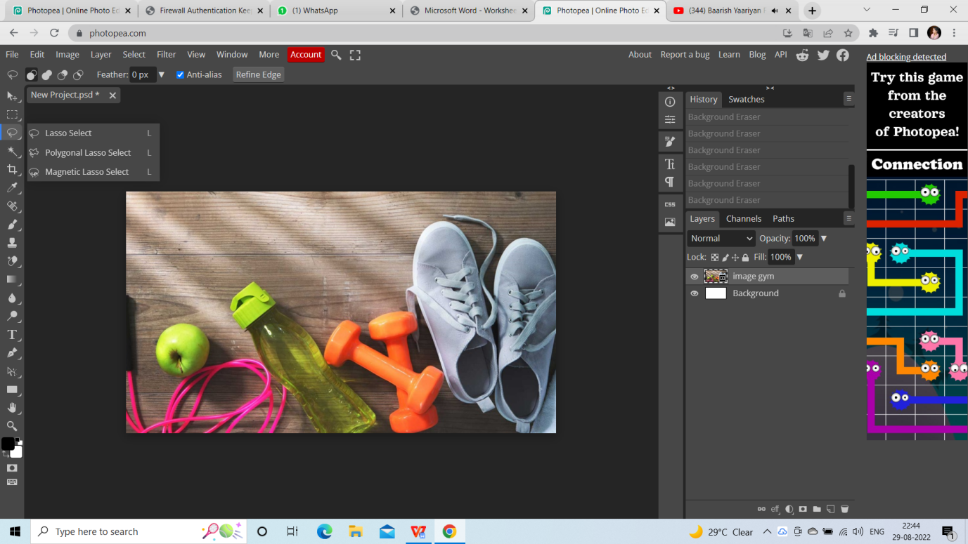

**Step5:-** Select Edit, and then fill.

**Step6:-** Fill, and then content Aware

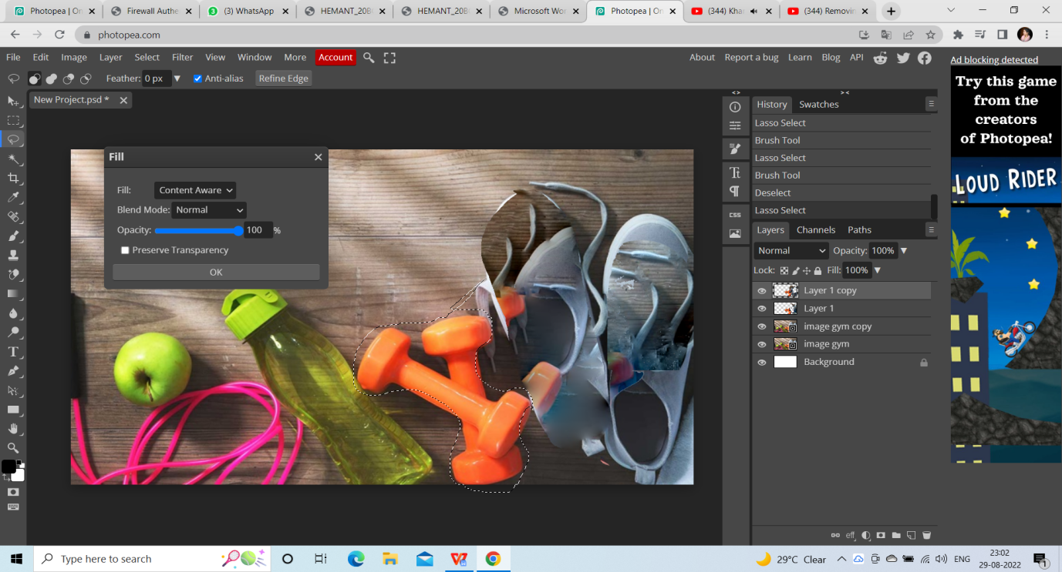

**OUTPUT**

**Step7:-** Object is removed from given image.

